**1. ATTACK NAME AND DESCRIPTION**

|  |  |
| --- | --- |
| INFORMATION SECURITY AND ASSURANCE  PROJECT DESIGN DOCUMENT | dICTIONARY ATTACK  Technique of breaking into a password-encrypted computer or a server by systematically providing every word in a dictionary as a password.  Sadanand Kallakuri (16231729); Sowmya Yelmati (16208737) |

**1.1 DICTIONARY ATTACK:**

A method used to break security systems, specifically [password](http://www.webopedia.com/TERM/P/password.html)-based security systems, in which the attacker systematically tests all possible passwords beginning with words that have a higher possibility of being used, such as names and places. The word "dictionary" refers to the attacker exhausting all of the words in a dictionary in an attempt to discover the password. Dictionary attacks are typically done with software instead of an individual manually trying each password.

**2. Attack Flow Diagram Overview:**

As shown in the below diagram we used kali Linux as our attacking machine and Ubuntu as victim machine. We chose to use Hydra tool to perform a dictionary attack. In order to perform the dictionary attack we used nmap to scan the open ports on the victim machine and found ftp and ssh ports are open on the machine. we used ftp port to do the attack using hydra. We created a password list which has several password including the actual password of victim machine. When we ran the Hydra command, the attack is successfully done and password is successfully cracked.

Now to defend the attack, we installed snort on the Ubuntu machine and tested it with sample snort rule (to detect the icmp pings). It worked successfully. We then wrote the snort rules to get the alerts and to reject the password attacks. Our snort rules implies that if the password tries are more than 5 times within the 60 seconds period , snort raises an alert and reject the password attempts given by the intruder.

In this way we successfully completed the task. Please go through the rest of the document for the output screenshots and commands used.

**2. ATTACK FLOW DIAGRAM:**

 

Used Pwd List to attack victim

Hydra Tool

Attacker:

192.168.65.101



Pwd attack is done on FTP or different ports of victim

 



Victim machine uses Snort to detect the attack and rejects the attack. Snort alerts the victim machine about the attack

Victim Machine:

192.165.68.100

**Sequence of events in the attack:**

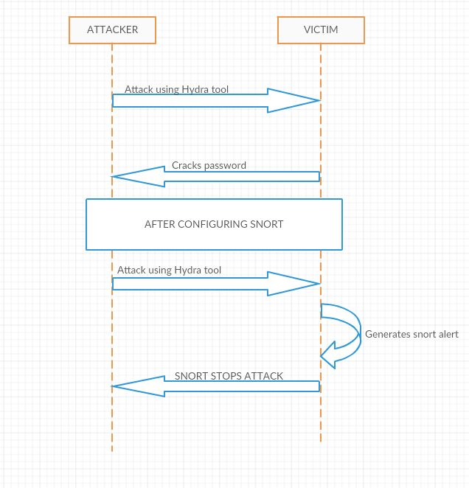

**3. PROJECT SETUP:**

For carrying out our attack, we have created two virtual machines using Opera box software. In this project, we have used Kali Linux as attacker machine and Ubuntu as the victim.

**3.1 VIRTUAL MACHINES & OS:**

For this project, we have installed Oracle VM Virtual Box Manager for creating virtual machines, needed for implementing our attack. We have downloaded Kali Linux and Ubuntu .iso files for creating the respective operating system based virtual machines.

1. **Attacking Machine :**

Operating System: Kali Linux

RAM: 1024 MB

Memory: 10 GB

Processors: 2

1. **Victim Machine :**

Operating System: Kali Linux

RAM: 1024 MB

Memory: 15 GB

Processors: 2

Ports Used: FTP, SSH

**Configurations:**

* We installed FTP and SSH services on the victim machine using the following command:

*sudo apt-get install vsftpd ,* then we edited the vsftpd.conf file to allow the anonymous users and then restarted the service.

* Now using Nmap from attackers machine we used command nmap –p- 192.168.65.100 and found that both ftp and ssh ports open on attacker’s machine

**4. TOOLS AND COMMANDS USED:**

For dictionary attack, **nmap** and **hydra** are used.

**4.1 NMAP**

Nmap (Network Mapper) is a free and open source utility for network discovery and security auditing. Many systems and network administrators also find it useful for tasks such as network inventory, managing service upgrade schedules, and monitoring host or service uptime. Nmap uses raw IP packets in novel ways to determine what hosts are available on the network, which services those hosts are offering, along with the operating system versions those systems are running. It can also detect the firewalls what type of packet filters/firewalls are in use, and dozens of other characteristics.

**4.2 HYDRA**

Hydra is a tool used to crack a remote authentication service by brute force. Hydra has the ability to carry out rapid dictionary attacks against many protocols such as telnet, ftp, http, https, ssh and many more. Hydra is very fast and flexible, and it makes the job of researchers and security consultants much more easy, for gaining unauthorized access to a system remotely.



**4.3 COMMANDS USED TO ATTACK THE VICTIM**

We have used the following command in the **hydra** tool installed in Kali Linux(Attack Machine) to attack Ubuntu(Victim Machine)**.**

**# hydra -l sowmya -V -P /usr/share/john/pwd.lst** <ftp://192.168.65.100>

* Here “**sowmya**”is the username of our Ubuntu machine.
* **“usr/share/john/pwd.lst”** is the path where our password list is stored.
* “**192.168.65.100**” is the IP address of the Ubuntu machine(Victim).

Before using the above command, we should configure **ftp** service on the Ubuntu machine. Also we have to include our original password along with some random passwords in the “**pwd.lst**” file.

**5. SNORT**

**Snort** is a open source Network Intrusion Prevention System(NIPS) and Network Intrusion Detection System(NIDS) used to perform real-time traffic analysis and packet logging on IP networks. Snort can perform protocol analysis along with content searching and matching. Snort also can be used to detect attacks, such as , operating system fingerprinting attempts,  [common gateway interface](https://en.wikipedia.org/wiki/Common_gateway_interface), [buffer overflows](https://en.wikipedia.org/wiki/Buffer_overflow), [server message block](https://en.wikipedia.org/wiki/Server_message_block) probes, and stealth [port scans](https://en.wikipedia.org/wiki/Port_scanner). Snort is generally configured in three main modes:

1. Sniffer mode.
2. Packet Logger.
3. Network Intrusion Detection.



**5.1 SNORT RULES**

The following are the snort rules which we have used in our project.

* Sample rule: **For detecting ping messages on victim machine**.

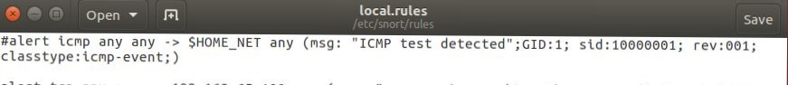

It detects icmp messages sent from Kali Linux to the Ubuntu machine.

* Alert rule: **To alert our victim machine if password tries are more than 5 times within the 60 seconds period.**



* Reject rule: **To reject the password attempts by the victim machine if password tries are more than 5 times within the 60 seconds period.**



**6. OUTPUT SCREENS**

* Configure Attacking machine(Kali Linux) and Victim Machine(Ubuntu), make sure that they are communicating with each other.
* The “**username**” of our Victim machine(Ubuntu) is “**sowmya”**.
* The “**password**” is “**mahesh1234**”
* Below screens show the IP addresses of both the machines.

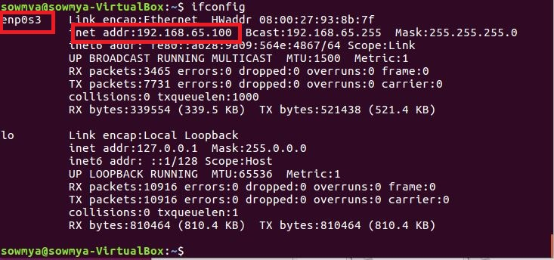

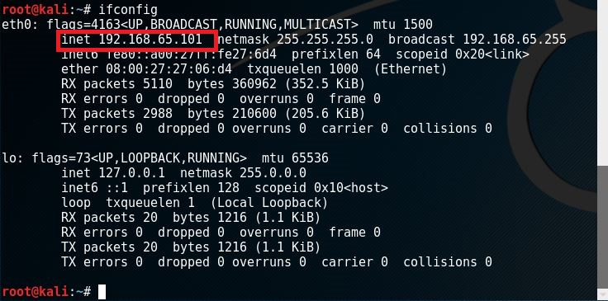

* Using nmap search for open ports on our victim machine.

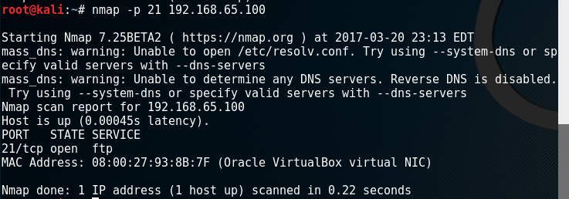

* **ftp** service on is active on victim machine(Ubuntu) as shown below.

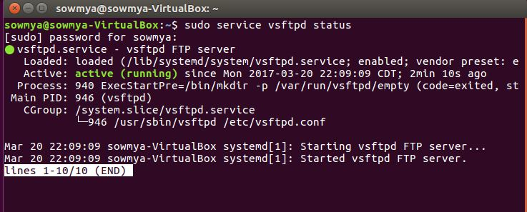Install snort on Ubuntu and use “**snort -V**” to check the installed version.

* Before moving forward we must modify the configure file for successful snort installation.
* Use the following command to open the snort configuration file.



* In the configuration file, make the following changes.

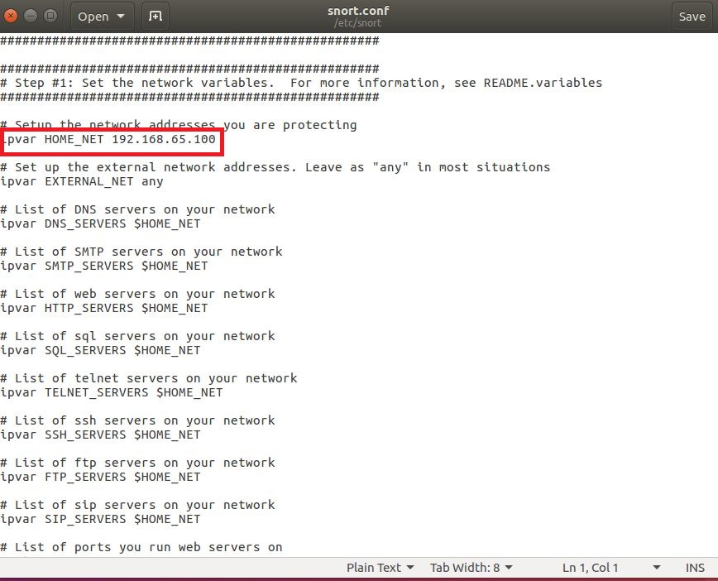

Provide the exact path for all the rule files:

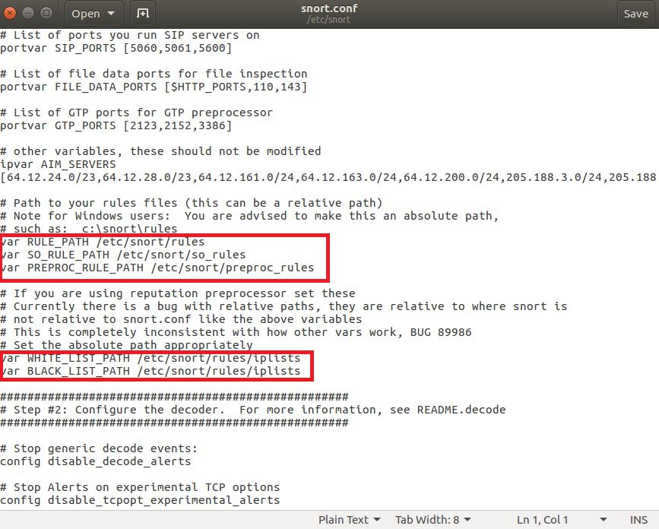

Provide path to save logs:

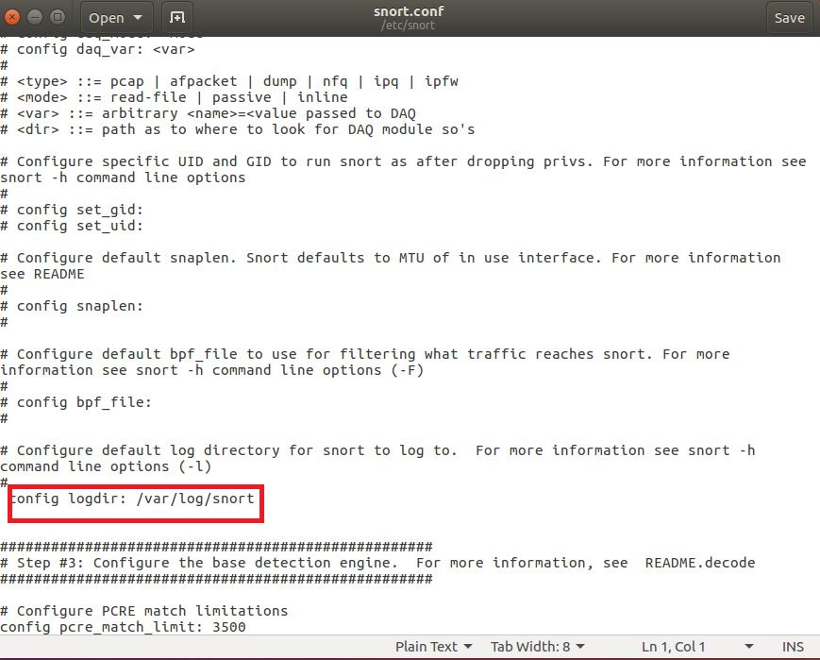

Uncomment the local.rule path so that snort will perform the operations based on given rules:

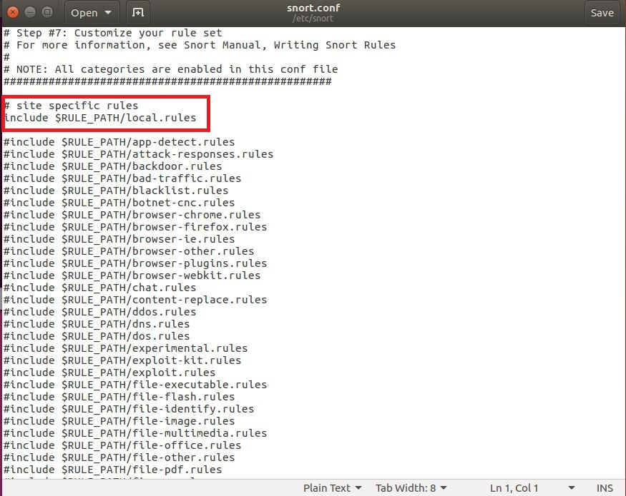

* Attack victim machine using hydra on Kali Linux.

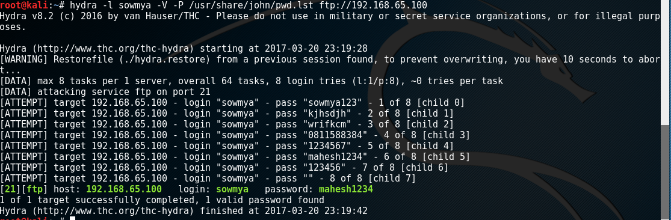

* As seen above, the password of victim machine is successfully identified.
* Now, on our victim machine, start snort for detection and rejecting the attack.
* The snort rules file can be accessed by typing in the following command.



* The snort rules file used in our project is shown below.

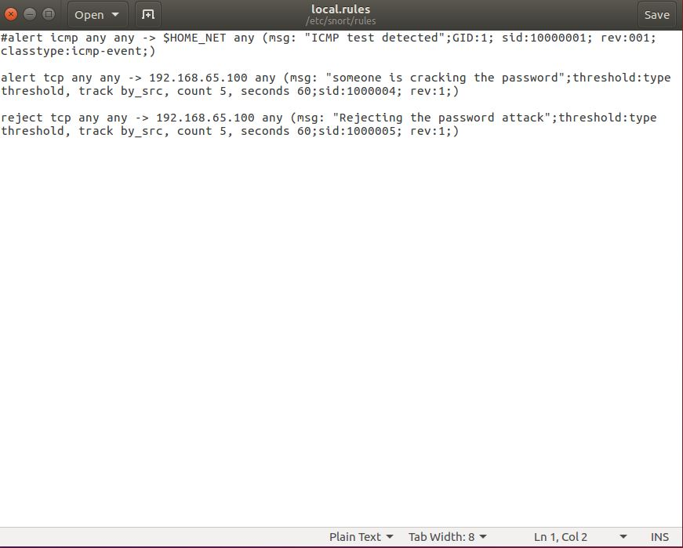

* In our snort file, the alert command is used to alert our victim that it is being attacked and the reject rule is used to stop the attacker machine from attacking.
* Now, use the following command to start snort on Ubuntu.



* Here “**enp0s3**” is the interface to which snort listens to.
* Now, on attacking the victim machine using hydra, Snort gives an alert in our victim, as shown below.

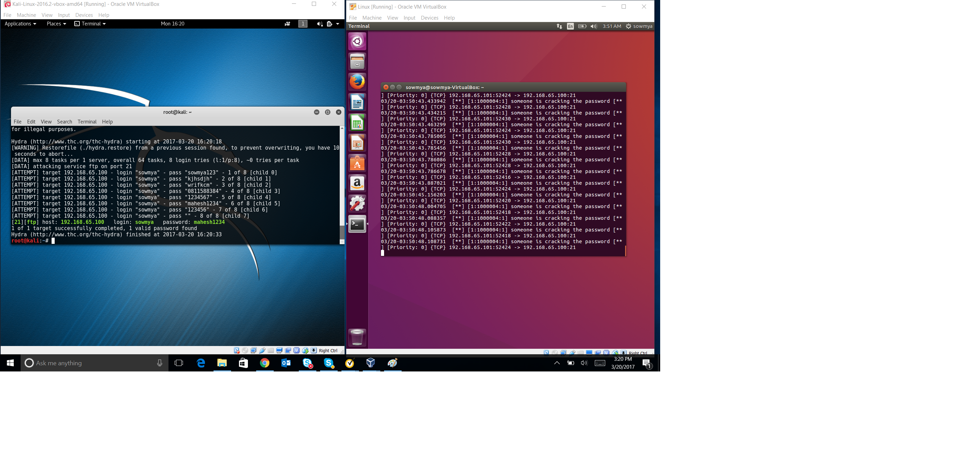

* As seen, the password is successfully cracked in the attacker machine, while the alert message is displayed on the victim machine.
* Now, we run snort by using snort rule file having only the reject rule. The results are shown below.

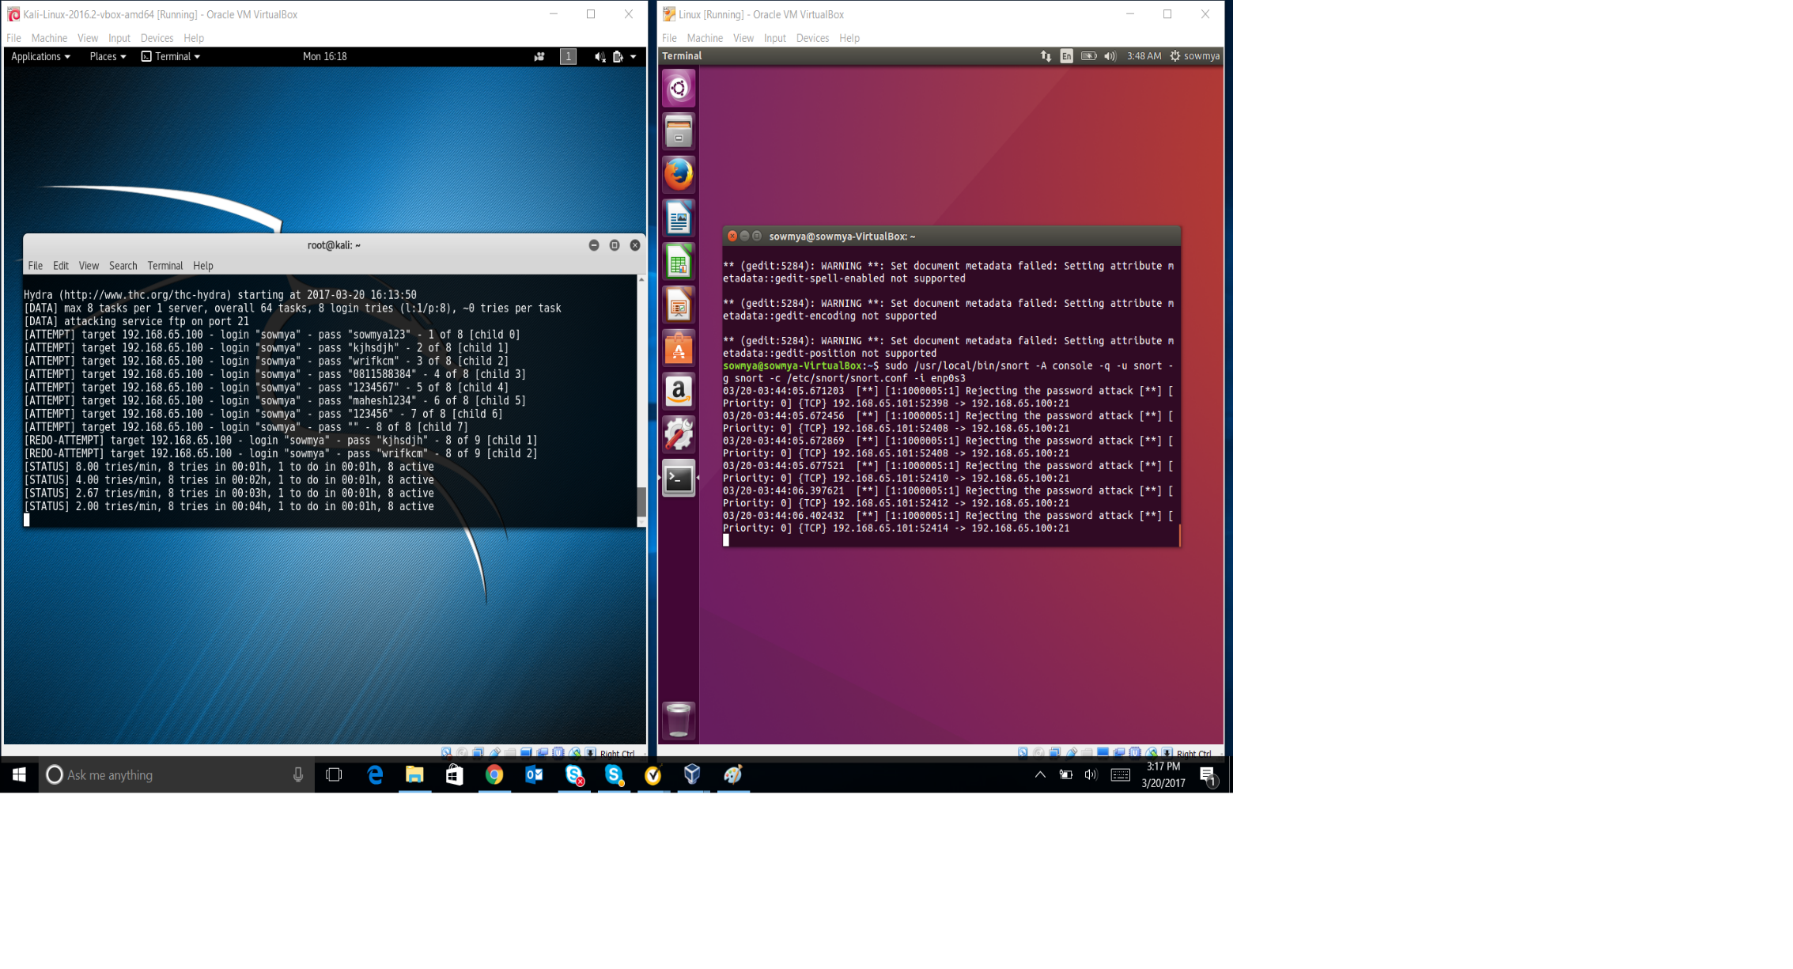

* As we can see above, as a result of the snort reject rule, the attacker machine is not able to crack the password despite multiple attempts and the corresponding messages being shown on the victim machine.
* To store the alerts on a log file, we used the following command.



* On running the above command, a log file is successfully created as shown below.

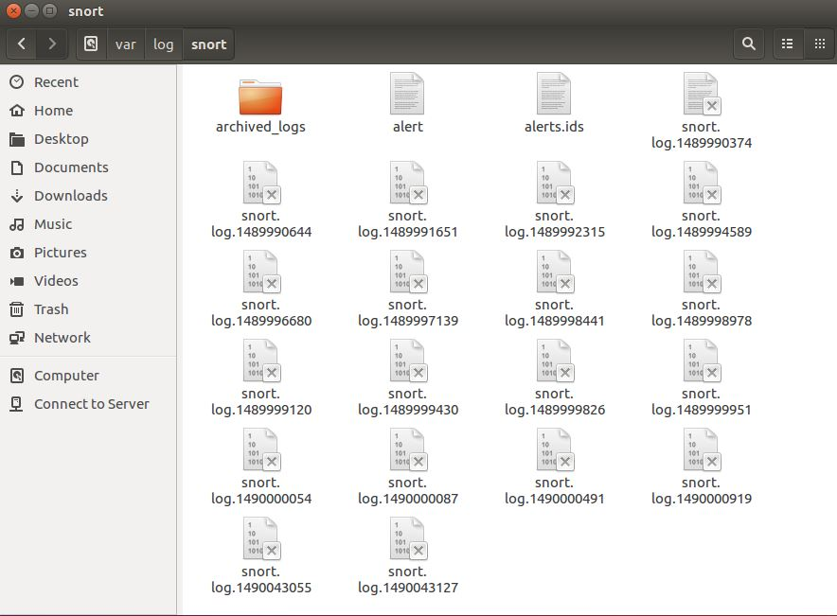

* Below screen shows the alerts file.

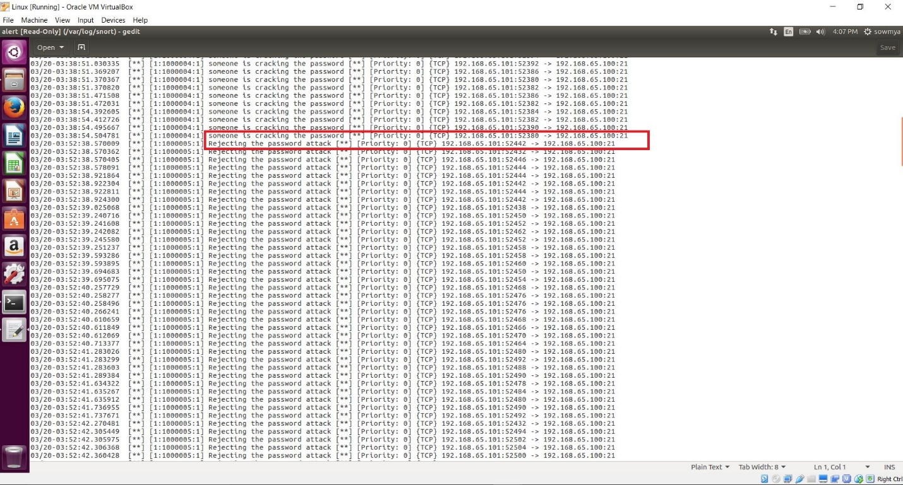

**Alerts File:**



**File in Text format:**



**Phase II:**

**Source code file(both in .java and .txt files):**

** **

**Instruction to run the code:**

**Step 1**: Open Eclipse. Go to File -> New -> Java Project. Give the Project Name as “Dictionary Attack” and click Finish. You need to have java 1.7 or higher installed in your system.

**Step 2**: Go to Windows in menu bar -> Perspective -> Open Perspective -> other -> java.

**Step 3**: Download the following jar file.



**Step 4**: In your project explorer, Right click on your project i.e. Dictionary Attack. Go to Build Path -> Configure Build Path -> Java Build Path (on left menu) -> Click on Libraries tab (on right).

**Step 5**: Click on “Add External Jars” Button. Browse the location of the above jar file (commons-net-3.1.jar) and click OK. Click Apply and OK.

**Step 6**: Right Click on project. Go to New -> Class. Leave the package as default package. Name your class as “FTPConnection” and click Finish.

**Step 7**: Copy and Paste the above given source code into your class.

**Step 8**: Download the following file and save it under “/root/Downloads” folder in your kalilinux machine.



**Step 9**: Now right click on your java class and go to -> Run As -> Java Application.

**Snort Rules(Same as Phase I):**

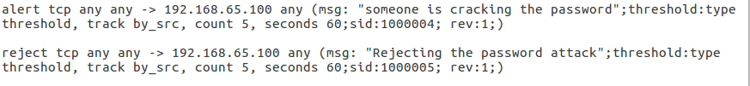

**Output Screens:**

Successfully established connection:

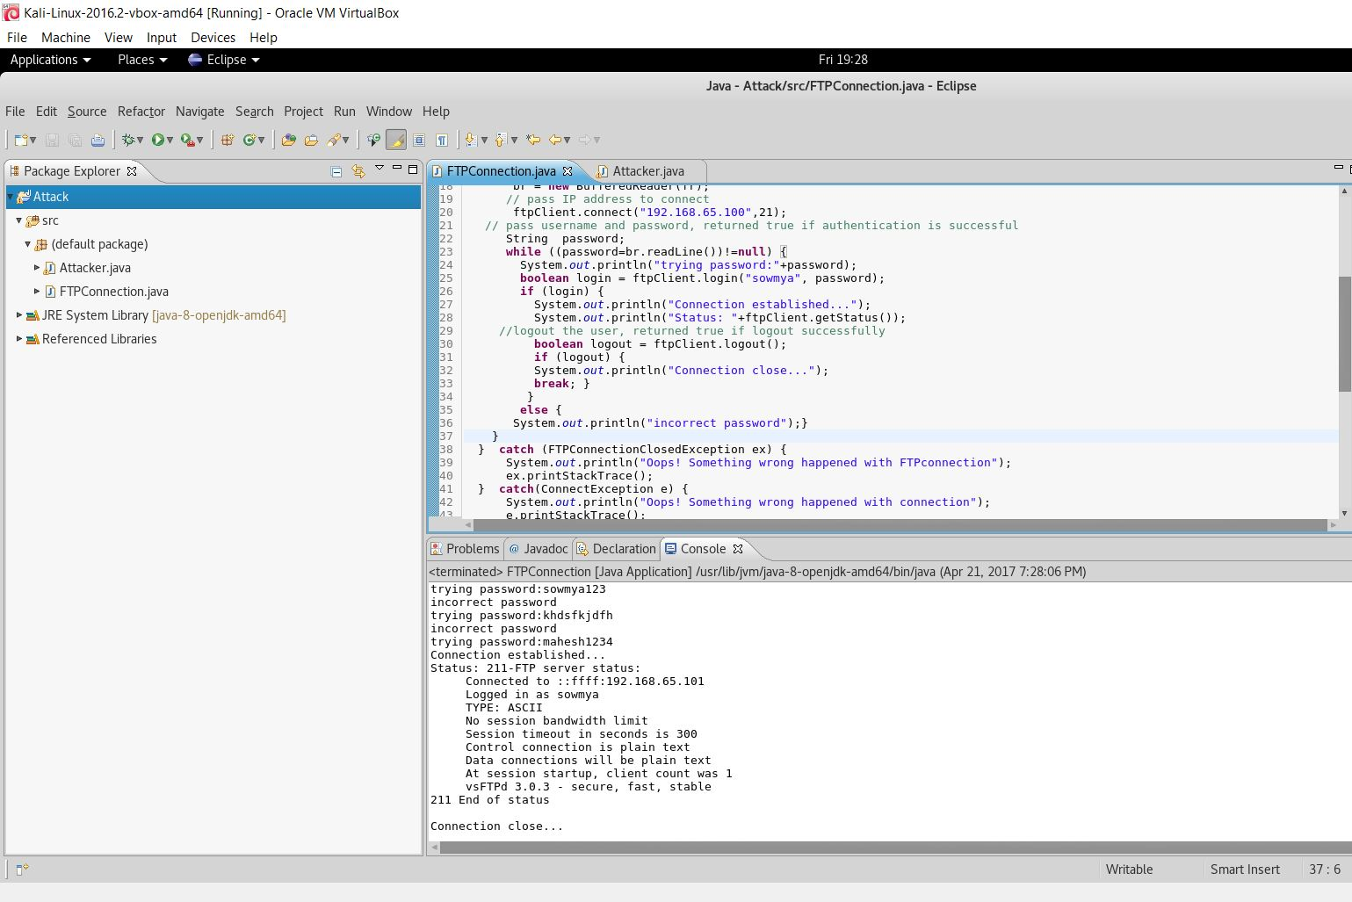

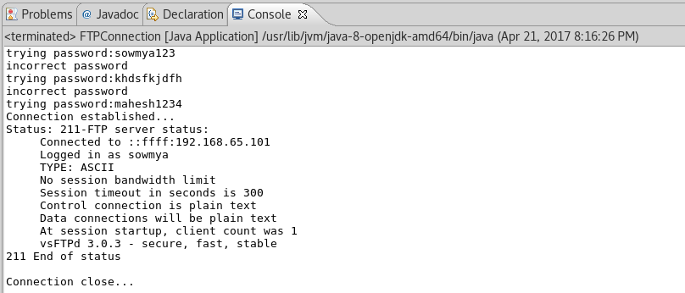

Started Snort on Victim Machine:

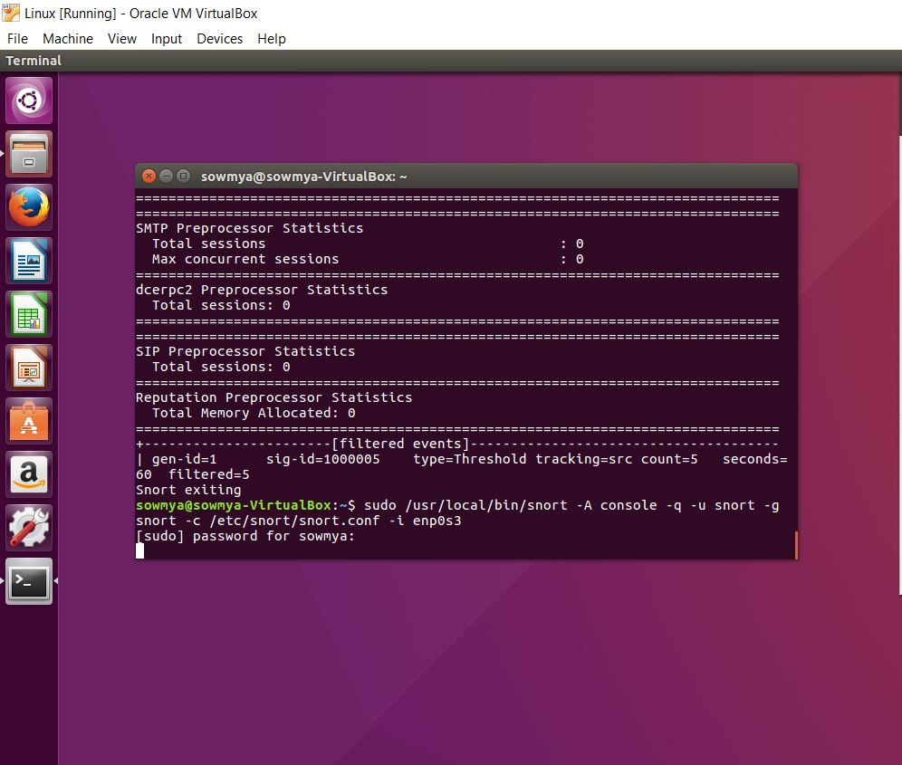

Output from (Attacker) code when Snort is running on victim machine:

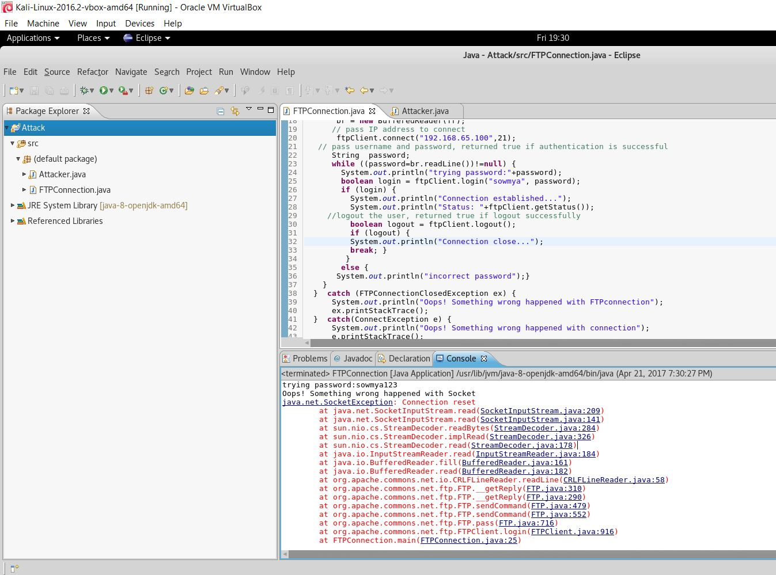

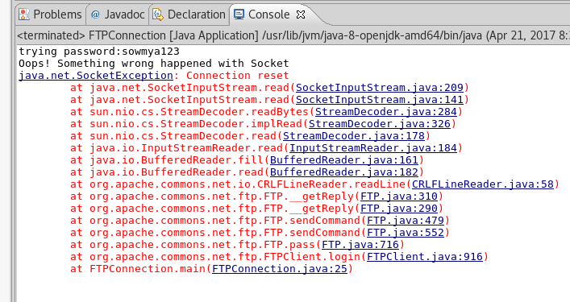

Snort messages logged on Console when Attacker is cracking the password:

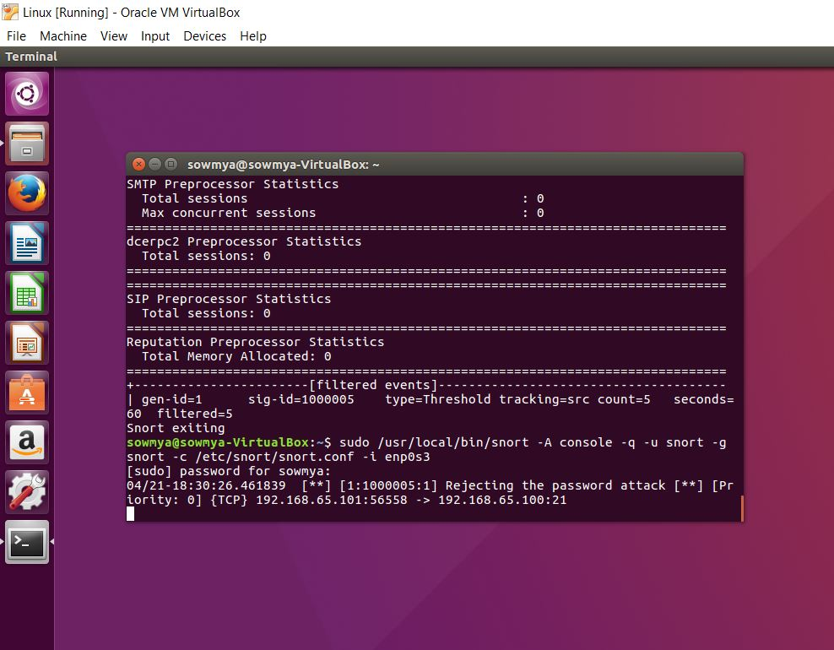

Messages in Alert.ids file:

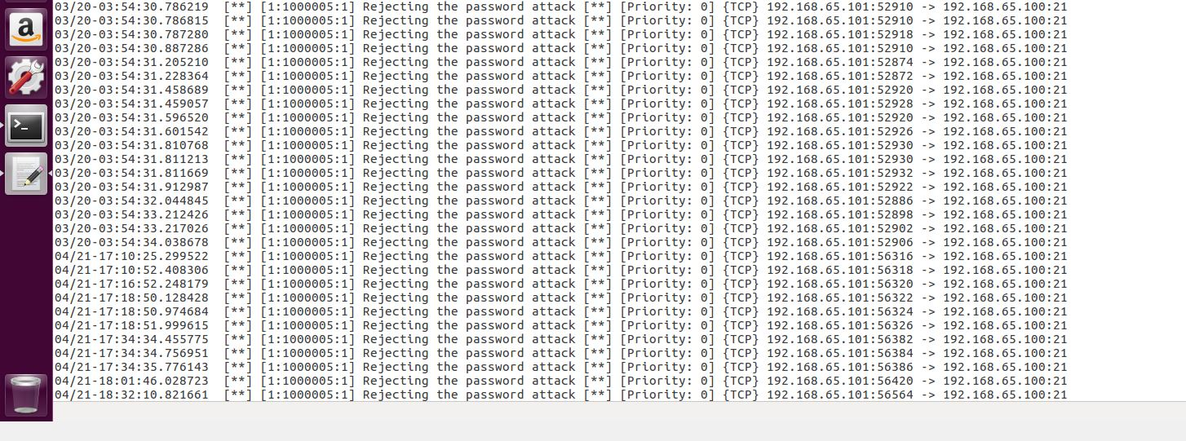

**Alert.ids File(Please note that messages are at the bottom of the file dated 4/21):**



**REFERENCES :**

[http://www.snort.org](http://www.snort.org/)

<https://www.youtube.com/watch?v=2Yiyeu7TFbQ>

<http://www.ubuntu-howtodoit.com/?p=138>

<http://www.webopedia.com/TERM/D/dictionary_attack.html>

<http://searchsecurity.techtarget.com/definition/dictionary-attack>

<https://nmap.org/>

<http://sectools.org/tool/hydra/>

<https://examples.javacodegeeks.com/core-java/apache/commons/net-commons/establish-connection-with-ftp-server/>